CURRICULUM VITAE

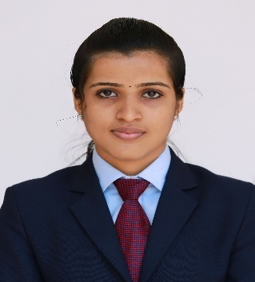
JINTO VARGHESE
Panachamala Puthen Veedu
Chayalodu P O, Nedumon
Adoor, Pathanamthitta (Dist)
Kerala
Pin: 691556
Email Id: jintovarghese057@gmail.com
Contact No: 9747755982
Career Objective
Looking for a position in the HR department of the reputed organization to start my career for the new learning and add some value to the profitability of the organization.
Profile Summary
- A customer oriented, multitasking fresher with MBA degree in HR.
- Expert in understanding the business requirement.
- Excellent in identifying the need of organization.
- Excellent in understanding and analyzing the human behavior.
- Proficient in coordinating with the people.
Key Skills
- My skill is my performance on my work.
- Self-motivated.
- Co- ordination skills
- Organizing Group
- Efficient Management skill
- Problem solving skills.
- Can work under pressure.
- Target oriented.
Computer Proficiency
- MS Office – Word, Excel, Power Point, Internet & E-mail operations.

Qualification
- MBA in Human resource from Marthoma College of Management and Technology, Perumbavoor under MG University in the year 2016.
- B.Sc Computer Science graduate from IHRD College of Applied Science, Konni in the year 2014 with 63 %.
- Higher secondary passed from St.Stephens HSS, Pathanapuram in the year 2011 with 70%.
- High school passed from St. Marys MMGHS, Adoor in the year 2009 with 75%.
Work Experience
Company : NIER, Adoor
Designation : Assistant HR Manager
Period : 10th July 2016 (working)

Awards and Achievements
- Second prize in Human Resource game in Management fest conducted by SNGIST, College, Paravoor.
- Reception Coordinator of the Fratres 2015.
- Attended international conference on the topic “Emerging trends in automobile industry” at Hotel Renai, Cochin.
- Attended the seminar on Innovative teaching learning method in 21st century education scenario at Marthoma college for women, Perumbavoor.
- Certificate program in Yoga.
Personal Profile
Date of Birth : 16-05-1993
Sex : Female
Nationality : Indian
Marital Status : Single
Languages Known : English, and Malayalam
Hobbies : Listening to music, Cooking, Gardening
Declaration

I do hereby declare that all the particulars given above are true and correct to the best of my knowledge and belief and that I have not concealed or distorted any information in this regard.

Place: Adoor
Date: JINTO VARGHESE

